:GREENSFELDER
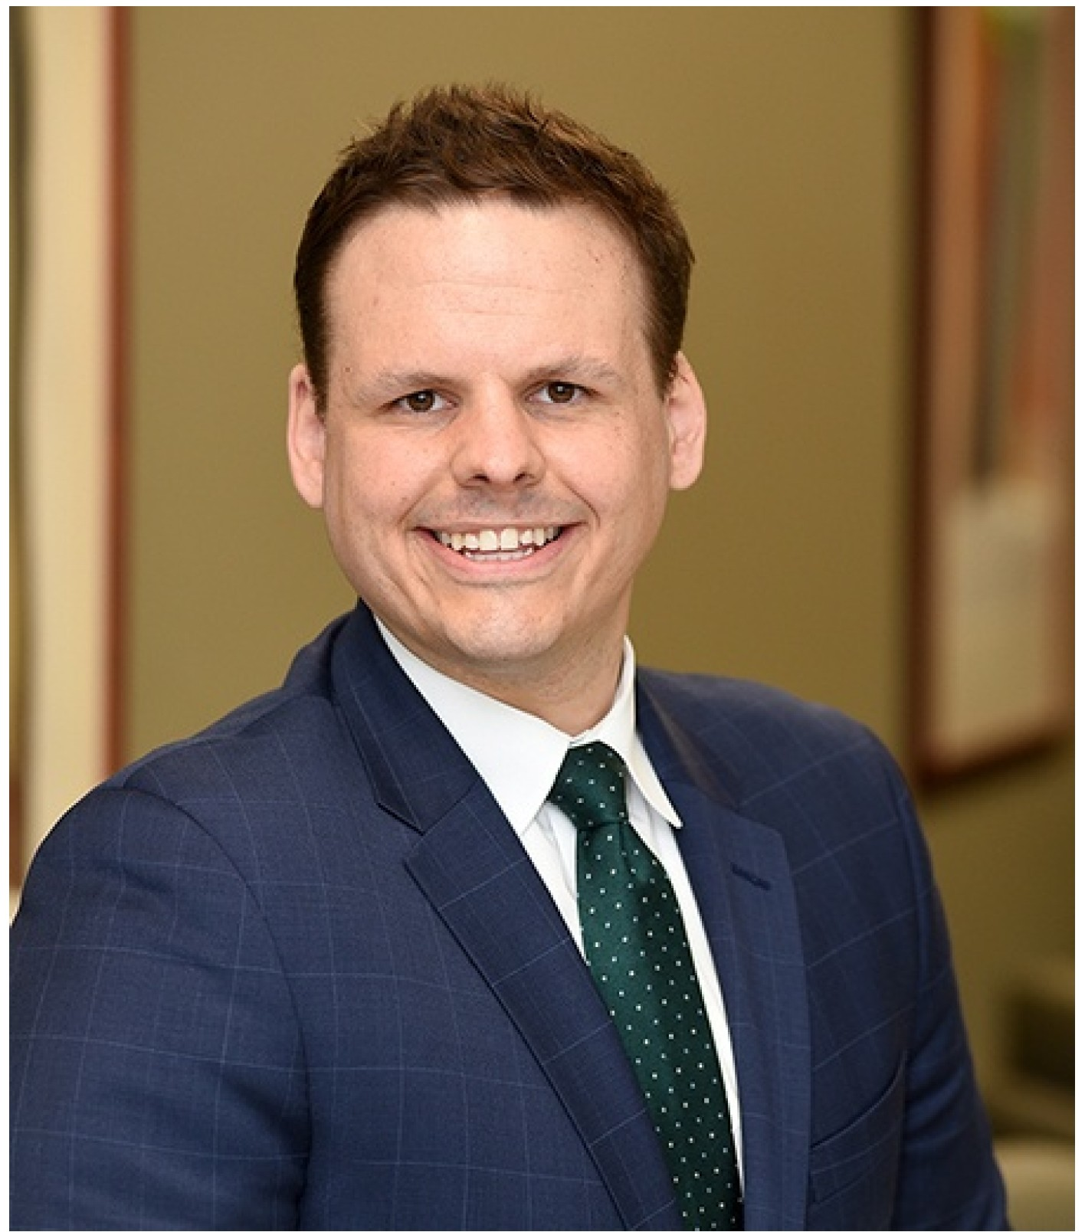
DANIEL R. RITTER
ASSOCIATE
St. Louis, MO dritter@greensfelder.comEmaiI p 314.345.4796
f 314.241.8624

"In helping navigate complex legal questions
and disputes} I work to learn each employer1s business and recommend the best practices to avoid conflict and achieve their goals."

Practice Areas
Employee Benefits
Employee Benefits Litigation
Employment & Labor Compliance Counseling
Employee Policies &
Training

Employment Class Action
Employment Contracts
& Agreements
l=mnln\/rm: nt I itin tinn
Dan Ritter counsels and defends businesses and organizations on employment and labor law matters of all types, providing assistance in litigation and disputes as well as day-to-day counsel. He has represented employers in a number of industries, including manufacturing, health care and energy. He handles issues related to state and federal discrimination lavvs, employee agreements and policies, human resources training and other areas key to employers of all sizes.

In addition to his employment law practice, Dan has litigation experience in product liability, insurance, and commercial actions_ He has assisted clients in a varietv of oractice

This website uses cookies to improve functionality and performance. If you choose to continue brovvsing this website, you consent to the use of cookies. Read our Privacy Policy here for details.

ACCEPT

Leave Management Trade Secrets Wage & Hour

Industries
Health Care

Admissions
Missouri Illinois
U.S. District Court for the Eastern District of Missouri
U.S. District Court for the Western District of Missouri
U.S. District Court for the Southern District of Illinois
U.S. District Court for the Central District of Illinois

Education
J.D., Washington University School of Law, Washington University Journal of Law& Policy, 2016

  - ., Political Science, Truman State University, magna cum laude, 2012
in a variety of practice groups allovvs Dan to consider the mix of legal and business issues different clients face.

Dan is an adjunct professor at Washington University School of Law, where he teaches Introduction to U.S. Law & Methods. He has worked for several government agencies as an analyst and legal intern, including the Department of Homeland Security, the Department of Agriculture, and the Department of Defense, giving him a strong background understanding of regulatory agencies.

PROFESSIONAL AFFILIATIONS
    - Bar Association of Metropolitan St. Louis
    - Federal Bar Association, Eighth Circuit Representative, Younger Lawyers Division

COMMUNITY /CIVIC ACTIVITIES
    - Migrant & Immigrant Community Action (MICA) Project, pro bona attorney

HONORS & AWARDS
Illinois State Bar Association Lincoln Award Legal Writing Contest, 2018
Wiley Rutledge Moot Court Competition: Golden Quill (Best Brief) & Semi-Finalist
Scholar in Law Award
CALI in Business Negotiation Theory & Practice Don Sommers Award in Professional Responsibility

PUBLICATIONS

Articles & Books
111 imitinn Dorcnn I Ii 1ricrlil""tinn· Tho lmn l""t nf "TI,roll RrictnL

This website uses cookies to improve functionality and performance. If you choose to continue brovvsing this website, you consent to the use of cookies. Read our Privacy Policy here for details.

ACCEPT

DR/ In-House Defense Quarterly, Summer 2017

BLOG POSTS
What's in the brownie? The Illinois Cannabis Regulation and Tax Act's impact on employers
SimplyHR I Employment & Labor Blog, July 29, 2019

Employers: Do you know about the updates to the 'Notification of Employee Rights under Federal Labor Laws' poster?
SimplyHR I Employment & Labor Blog, June 11, 2019

